# **Name: Abdurrahman Qureshi**

# **Roll No: 210451**

Practical No: 16

1. **Factorial using Recursion**

**CODE:**

Public Class Form1

Function Fact(ByVal number As Integer) As Integer

If number <= 1 Then

Return 1

Else

Return number * Fact(number - 1)

End If

End Function

Private Sub Button1_Click(sender As Object, e As EventArgs) Handles Button1.Click

Dim Factorial As Integer = Fact(Integer.Parse(TextBox1.Text))

Label2.Text = Factorial

End Sub

Private Sub Button2_Click(sender As Object, e As EventArgs) Handles Button2.Click

TextBox1.Text = ""

End Sub

End Class

**OUTPUT:**

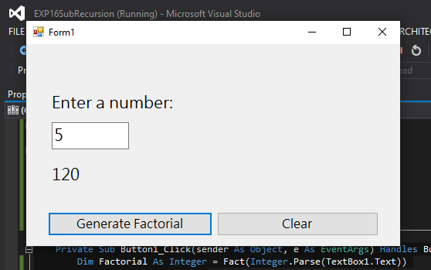

1. **Checking for greatness**

**CODE:**

Public Class Form1

Function GetMax(ByVal num1 As Integer, ByVal num2 As Integer) As Integer

If num1 > num2 Then

Return num1

Else

Return num2

End If

End Function

Private Sub Button2_Click(sender As Object, e As EventArgs) Handles Button2.Click

TextBox1.Text = ""

TextBox2.Text = ""

End Sub

Private Sub Button1_Click(sender As Object, e As EventArgs) Handles Button1.Click

Dim G As Integer = GetMax(Integer.Parse(TextBox1.Text), Integer.Parse(TextBox2.Text))

Label2.Text = "Greater Number --> " & G

End Sub

End Class

**OUTPUT:**

